

**Mawlana Bhashani Science and Technology University**

**Lab-Report**

Report No: 05

Course code: ICT-4202

Course title: Wireless and Mobile Communication Lab

Date of Performance:

Date of Submission:25.09.2020

**Submitted by Submitted To**

Nazrul Islam

Assistant Professor

Dept. of ICT

MBSTU.

Name:Ismayel Hossen

ID:IT-16054

4th year 2ndsemester

Session: 2015-2016

Dept. of ICT

MBSTU.

**Experiment No: 05**

**Experiment Name:** **Comparative Analysis of Wired and Wireless data using Wireshark**

**Objectives:**

1. We have to find out the Wired data packages Using the Wireshark in order to compare with the wireless data packages.
2. Filter the packages
3. Find out the host, IP of the data packages
4. Create the Statistics for both of the data packages.
5. Finally compare the wired and wireless data packages simultaneously with the help of Wireshark.

**Capturing Packets:**

If we click any menu option, then it will show the available interfaces list.

After clicking the menu, we need to start Capturing on interface that has IP address/Source/Host.

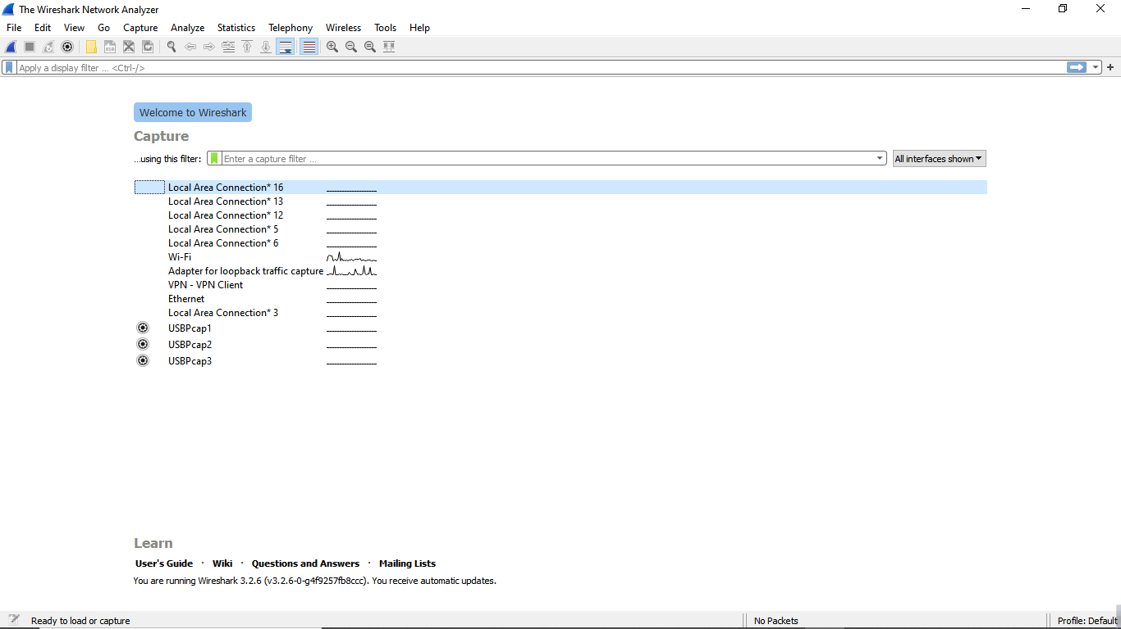

**Figure 01: Wireshark Interface List**

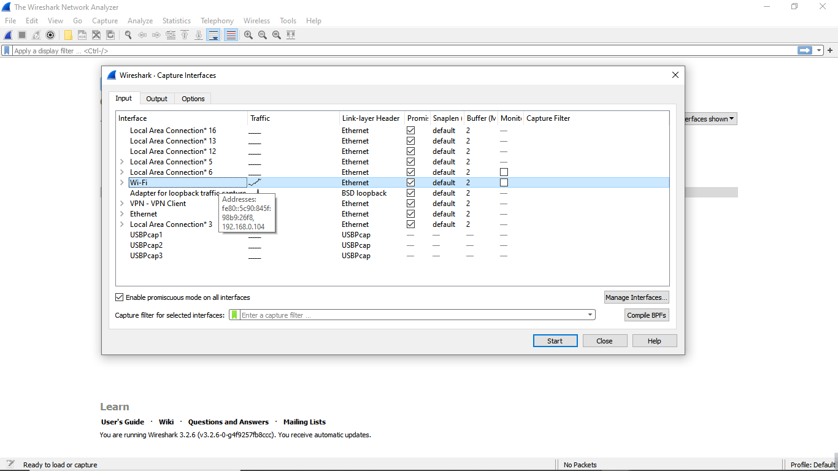

**Figure 02-A: Start Capturing Interface that has for Wi-Fi (Wireless)**

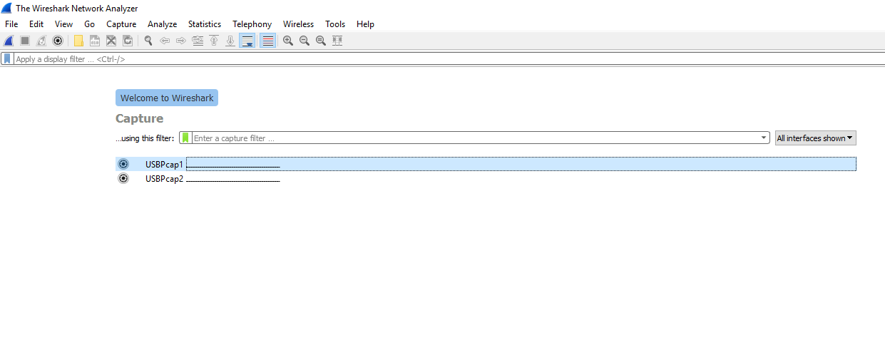 **Figure 02-B: Start Capturing Interface that has for USB Tethering(Wired)**

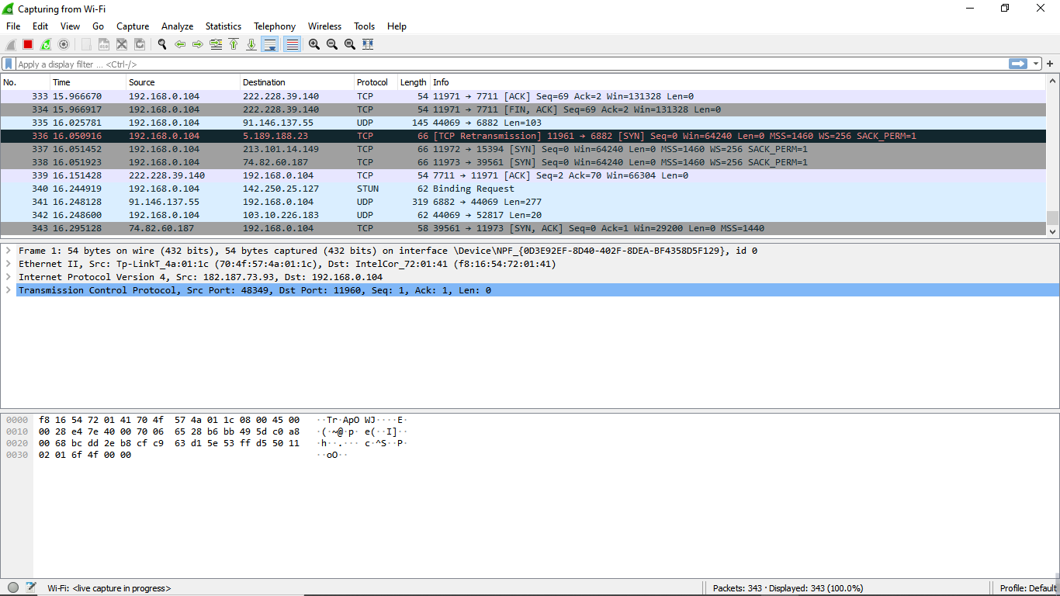

Packet bytes pane

Packet details pane

Packet list pane

**Figure 03-A: A sample packet capture window for Wireless Data Pack**

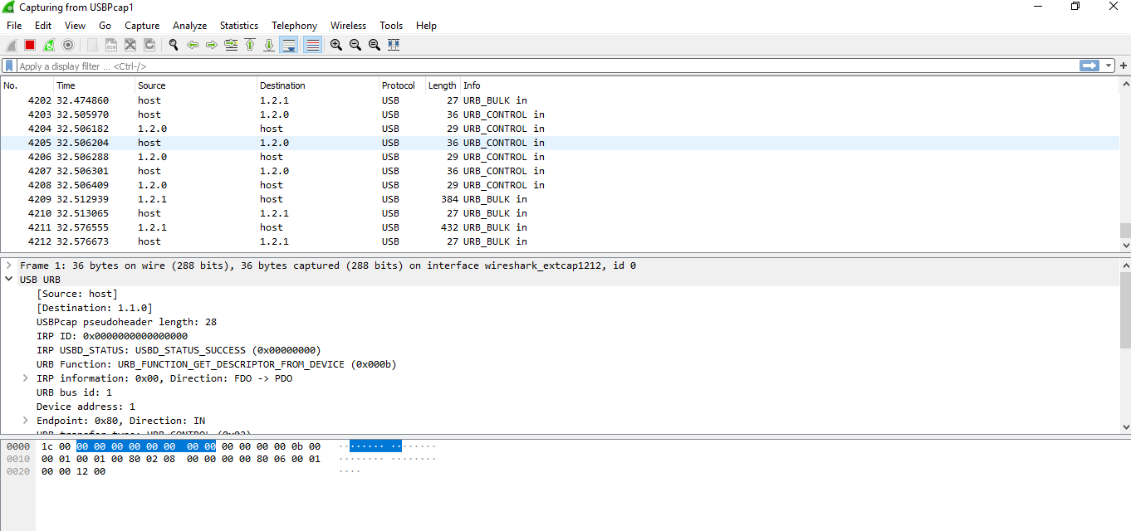

**Figure 03-B: A sample packet capture window for Wired Data Pack**

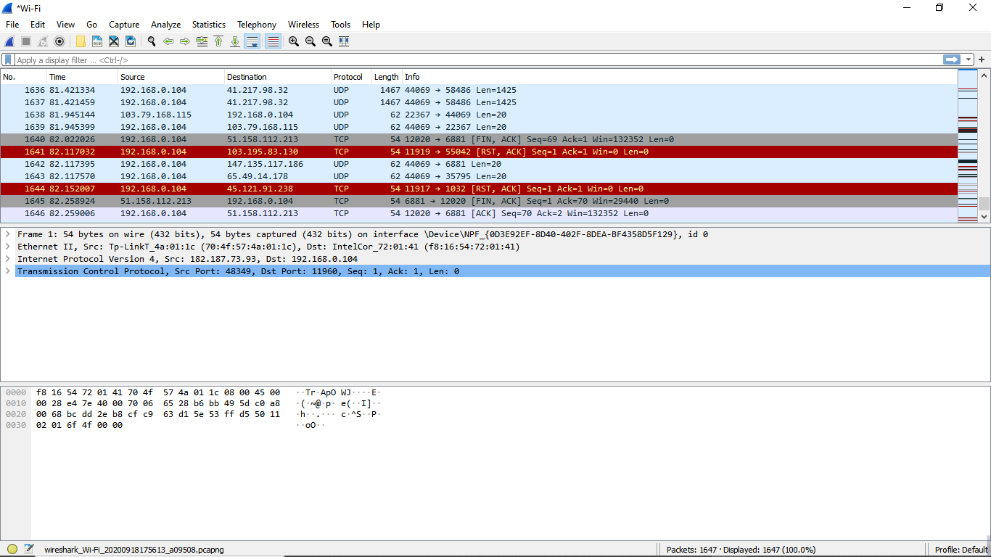

**Figure 04-A: Stopping Capture for Wi-Fi (Wireless)**

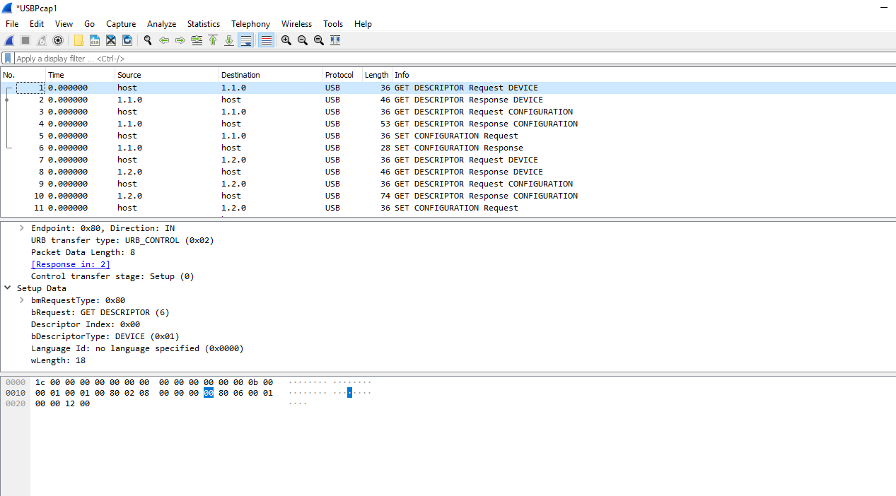

**Figure 04-B: Stopping Capture for Wi-Fi (Wired)**

**Filtering:**

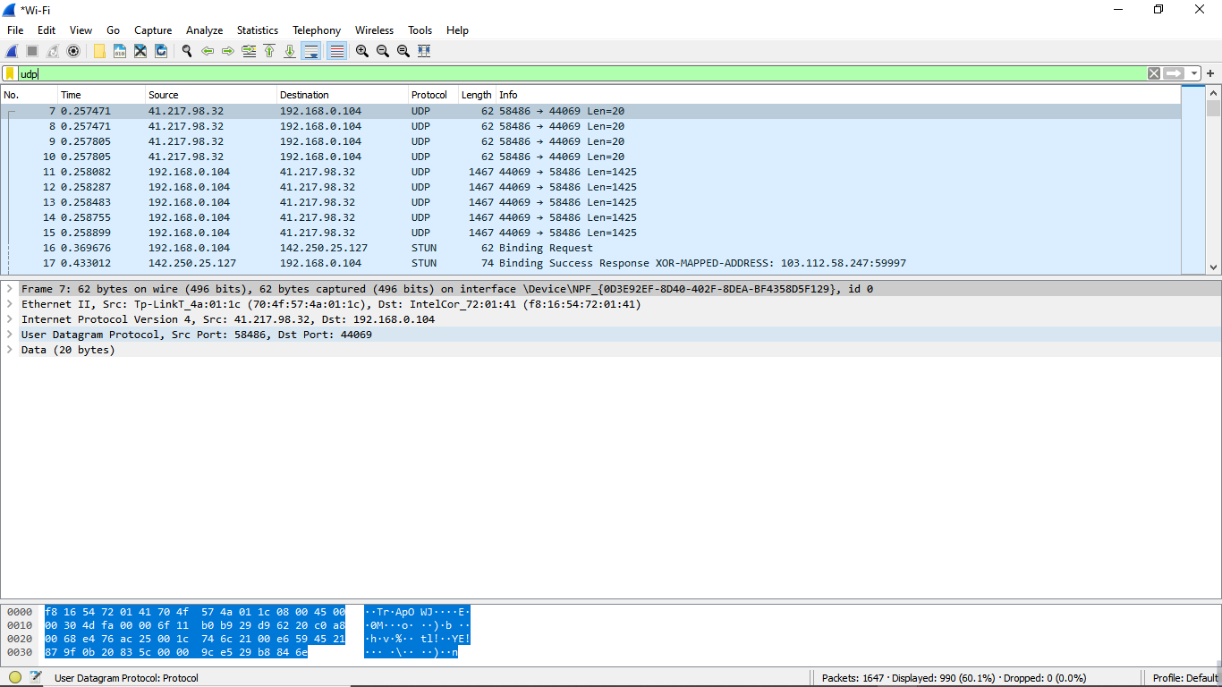

**Figure 05-A: Filter by Protocol Wireless Data Packages**

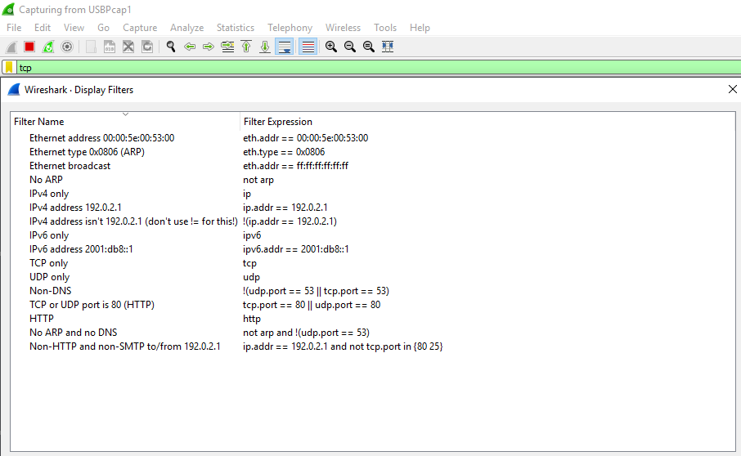

**Figure 05-B: Filter by Protocol Wired Data Packages**

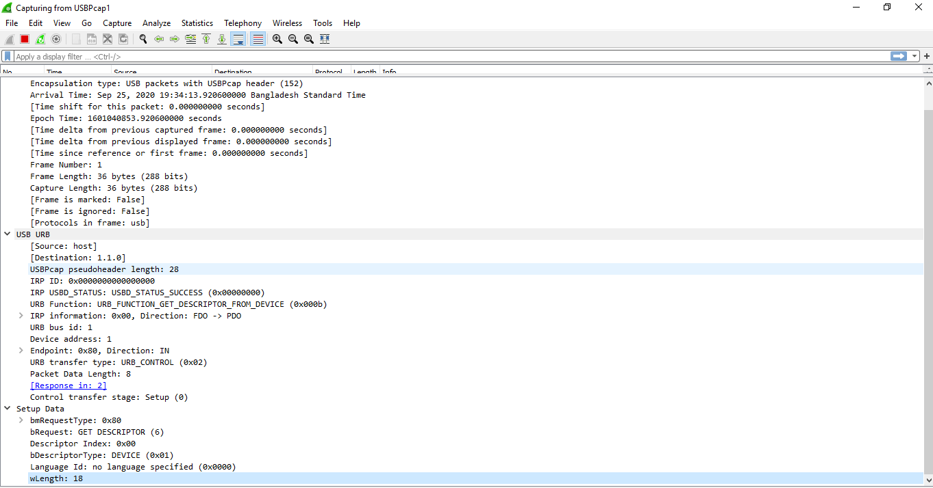

**Figure 06-A: Packet Details Pane (Frame segment) for Wired Data Packages.**

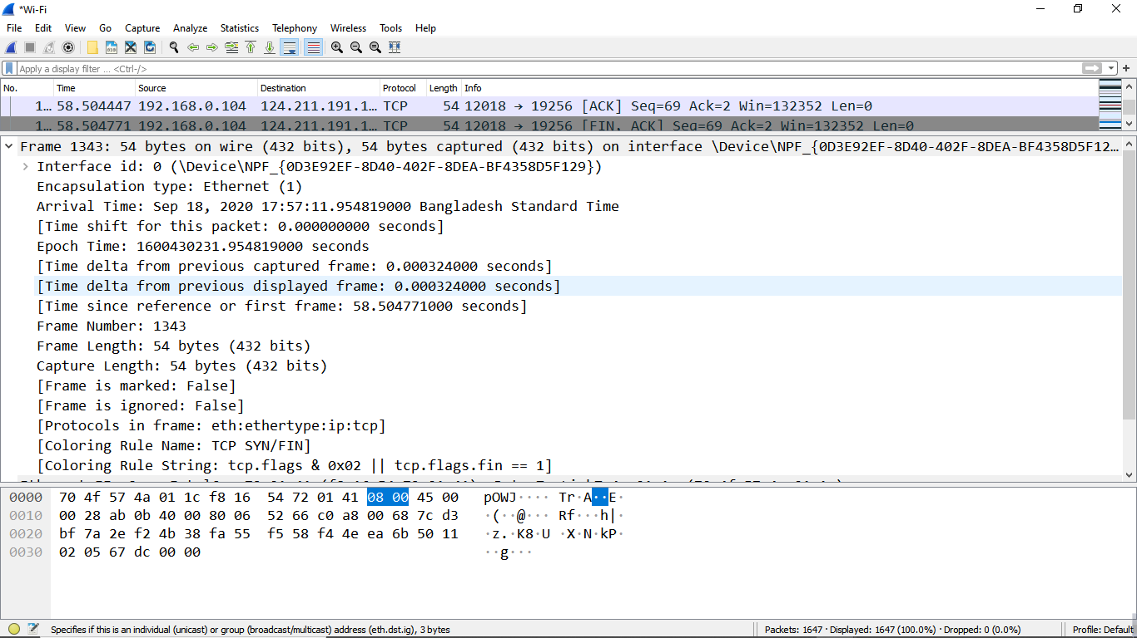

**Figure 06-B: Packet Details Pane (Frame segment) for Wireless Data Packages.**

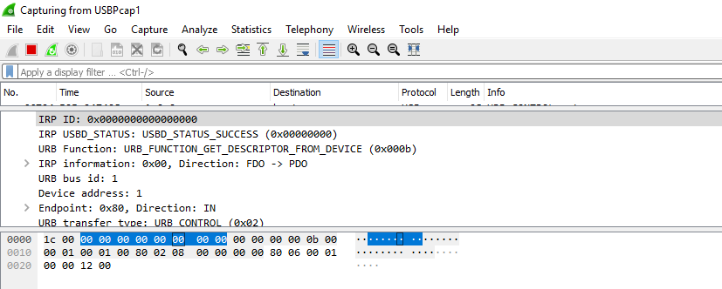

**Figure 07-A: Packet Byte Pane for Wireless (USB Tethering)**

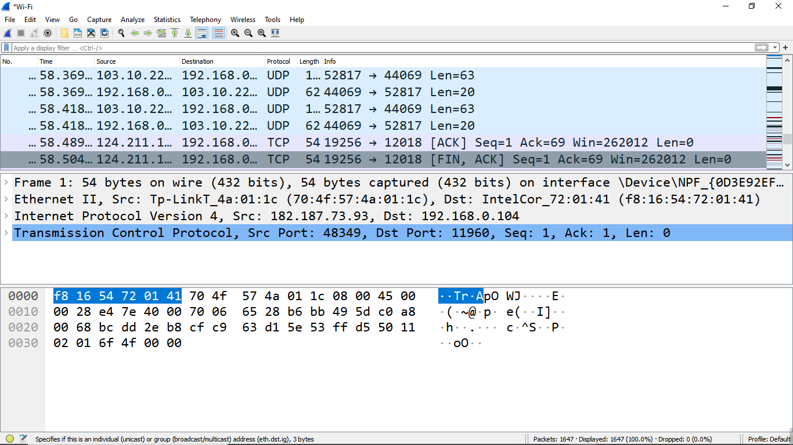

**Figure 07-B: Packet Byte Pane (For Wi-Fi)**

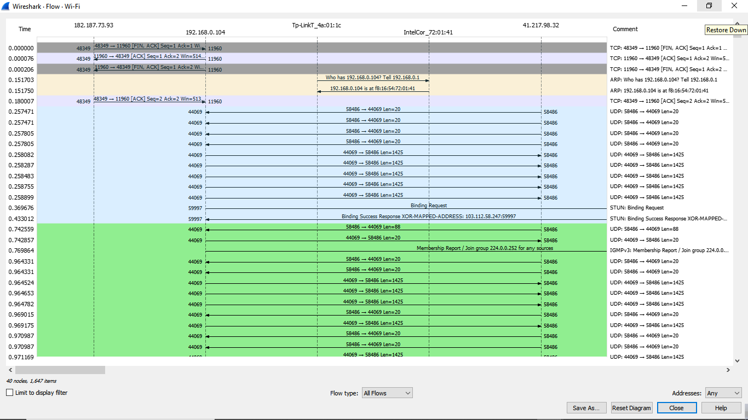

**Figure 08-A: Statistics- Flow Graph -All Flows for Wi-Fi (Wireless Data Packages)**

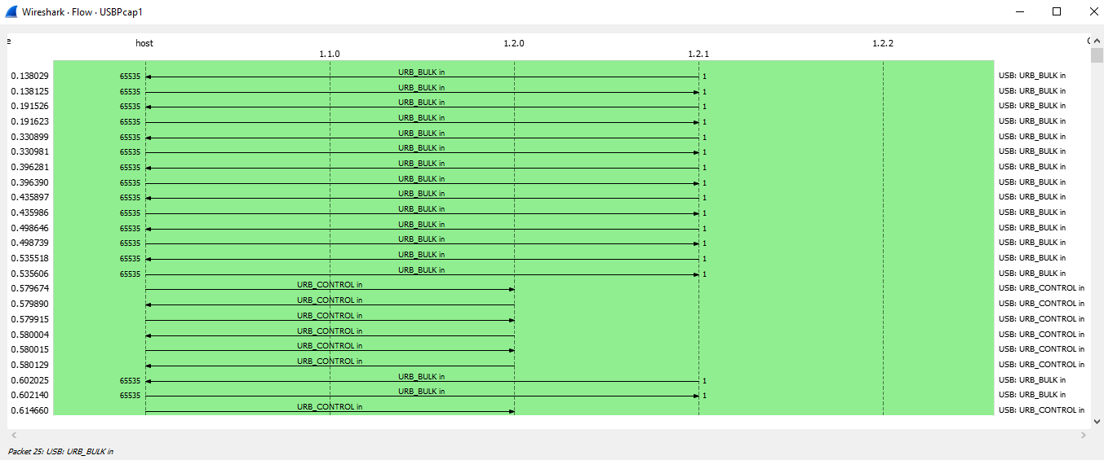

**Figure 08-B: Statistics- Flow Graph -All Flows for Wi-Fi (Wired Data Packages)**

**Conclusion:**

Between Wired and Wireless Network, wired network is much more efficient than wireless network. Because Wired data packages transfer rate are very much smoother than Wireless.

Wired data are more secure and high speedy, On the other hand wireless data are less secure and low speedy.